Starting The Conversation

When trying to connect the Patient Family Resource Center’s conference room to Zoom this process can help guide you through using the touch panel

When the Screen has not been used recently touching the screen will wake it. Make sure you see the Room Name at the top left corner of the screen and the call, share, or join options below
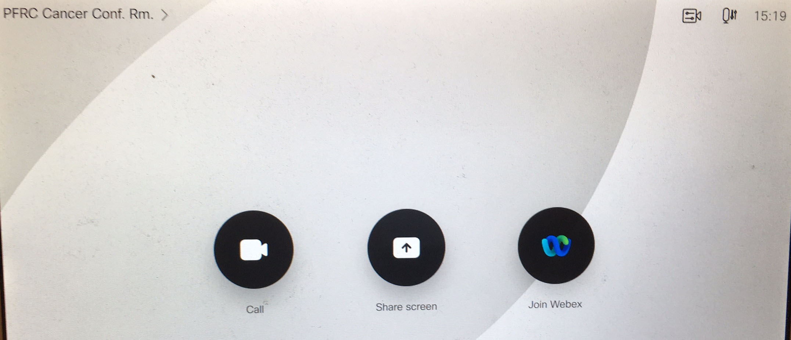

After pressing Call you will have options to join known rooms or Dial a MeetingID@zoomcrc.com
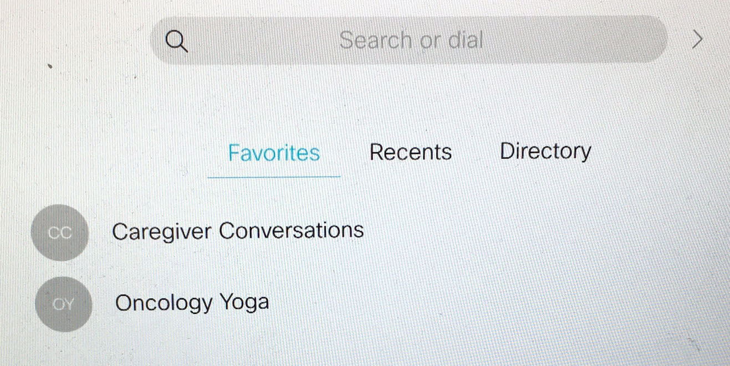

When a Webinar is selected options for it will appear at the bottom right
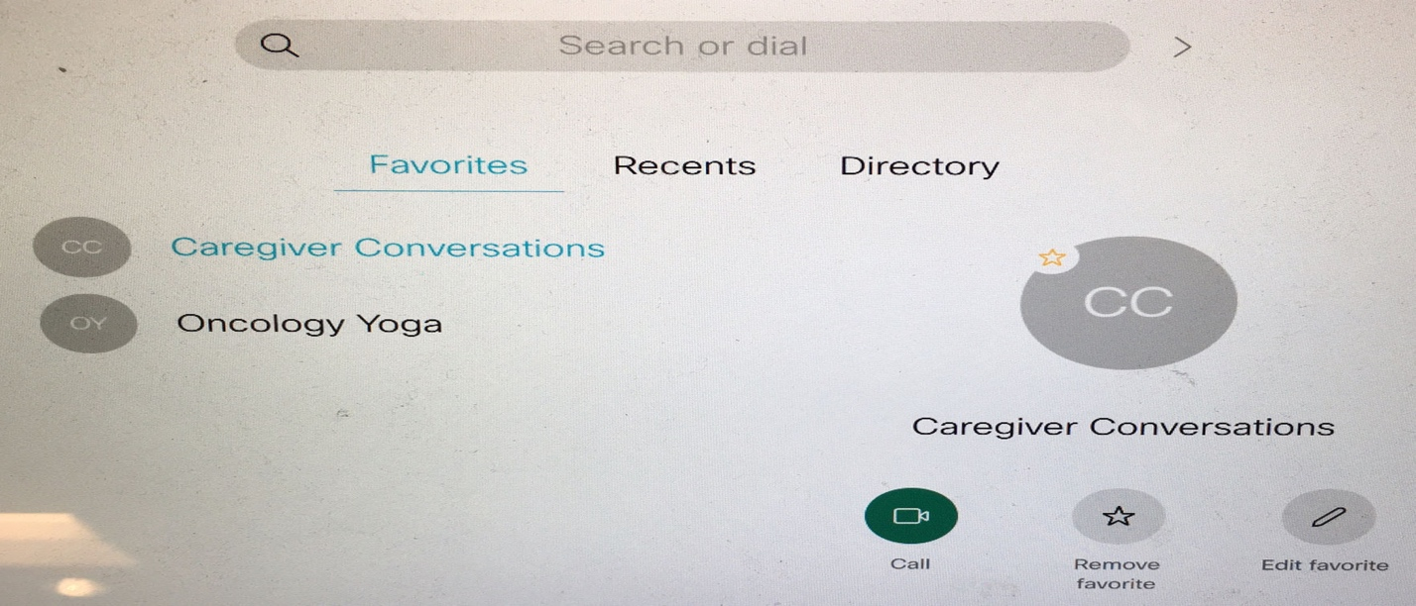

Press Call again and enter the meeting passcode from Zoom on the Keypad followed by the pound symbol twice(##)
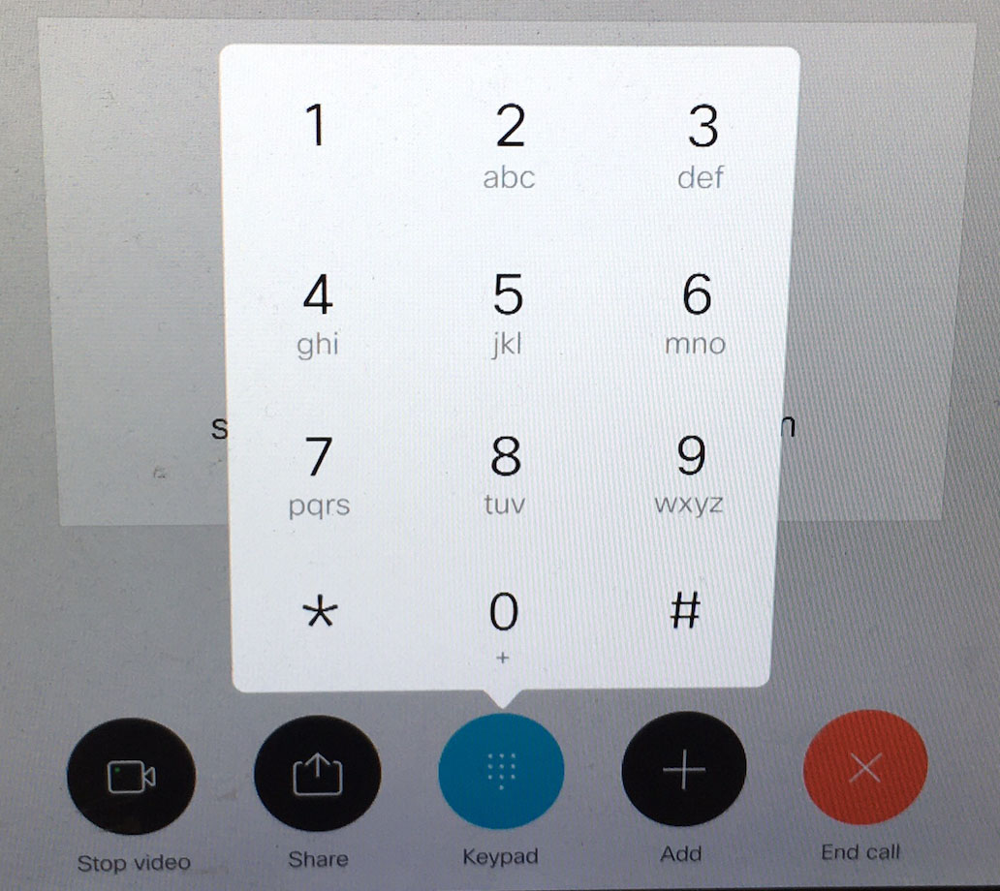

At this point you will have successfully joined virtually
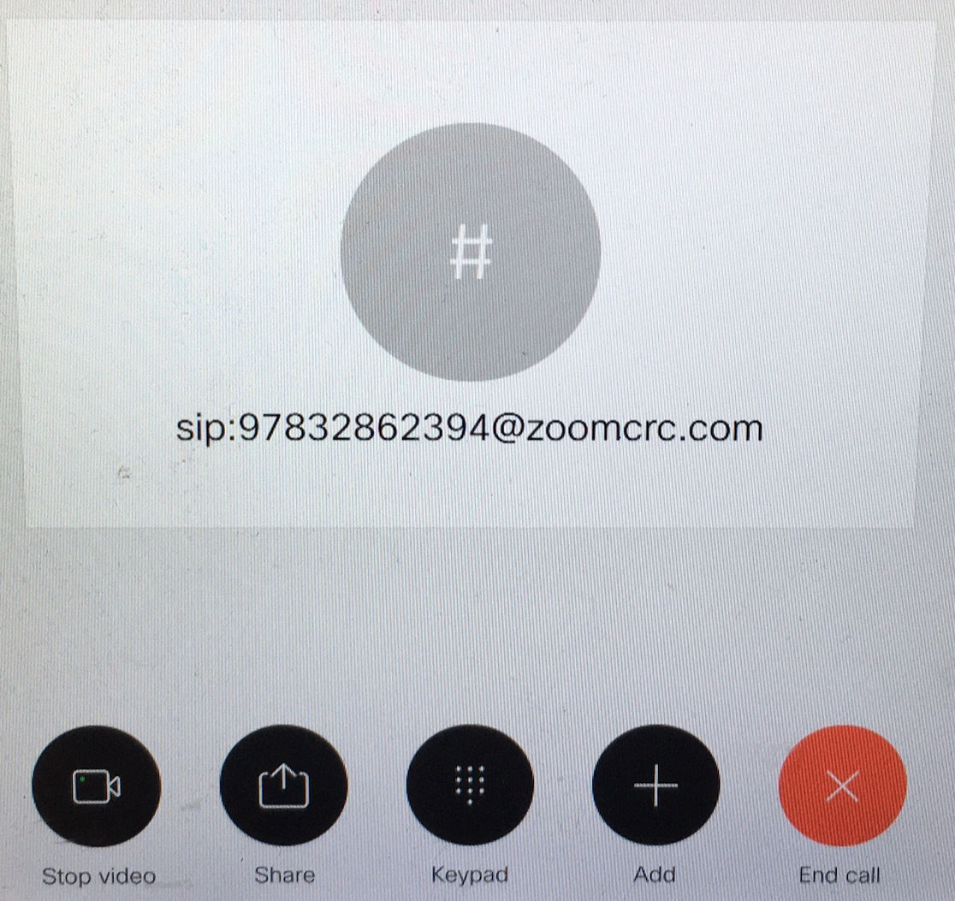

If you wish to share content with your audience you may press share then share in call
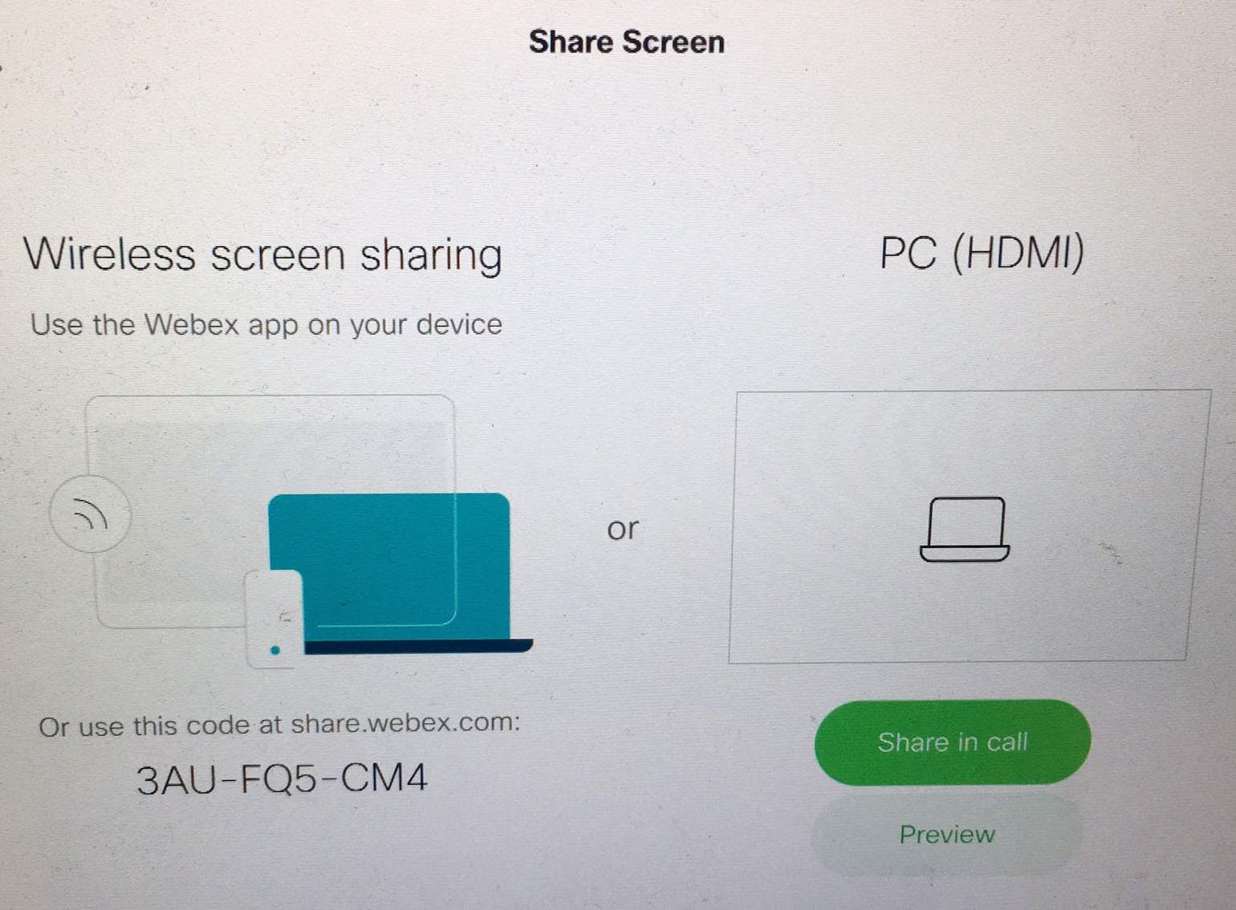

When you are ready End call will disconnect the room and allow for the next event to begin

