Case Study # 4 Cell Injury and Death

Background:
John is a sixteen-year-old high school student who is interested in trying out for the school wrestling team. One week before tryouts he badly sprains his back-playing touch football.

He is in considerable pain and is concerned that he will not be able to make the team. He visits his physician who confirms that the injury is not serious but quite painful. To relieve John’s discomfort, the physician prescribes a mild opiate anti-inflammatory medication (Endocet™ 7.5/500, 24 pills).

John is instructed to take two pills three times a day for pain relief. Concerned about his ability to compete for the team, John takes the pills four times a day until he runs out. In addition, he self-medicates with extra strength acetaminophen (Tylenol™), taking three pills every four hours in combination with the Endocet™.

On the weekend previous to his injury, John attended a party and overindulged in drinks containing alcohol. Four days after seeing his physician, John becomes severely nauseated, sweaty, and “flulike.” John’s mother notes that he seems sluggish and confused and brings her son to the local emergency room.

At the ER:
In the emergency room, the physician carefully reviews John’s history of medication. John’s liver is noted to be tender and mildly enlarged on physical examination. The physician is concerned about possible drug toxicity.

- What are two possible toxic agents mentioned in the case?
- What are some risks associated with self-medication?

Concerned about hepatic toxicity, the physician orders liver function tests that indicate acute liver failure. A serum acetaminophen assay discloses a potentially toxic amount of the drug.

- What are liver function tests? What is serum acetaminophen?

John is treated on an emergency basis with oral N-acetylcysteine (about this later) and medication to control nausea. He recovers with normalization of liver function tests over the period of several weeks. He does not make the wrestling team.

Discussion:
What does the liver do?
■■ Storage of glycogen, iron, copper, triglycerides, and lipid-soluble vitamins
such as B12.
■■ Synthesis of certain serum proteins including albumin, proteins important
in coagulation and inflammation, and binding proteins for many of the substances
stored.
■■ Metabolism of glucose and free fatty acids.
■■ Catabolism of both endogenous substances, such as hormones, and exogenous
toxic agents. The liver also removes ammonia derived from amino acid
breakdown.
■■ Excretion and production of bile.

Which function was most important in this case?

How can the liver be injured and what are possible results?
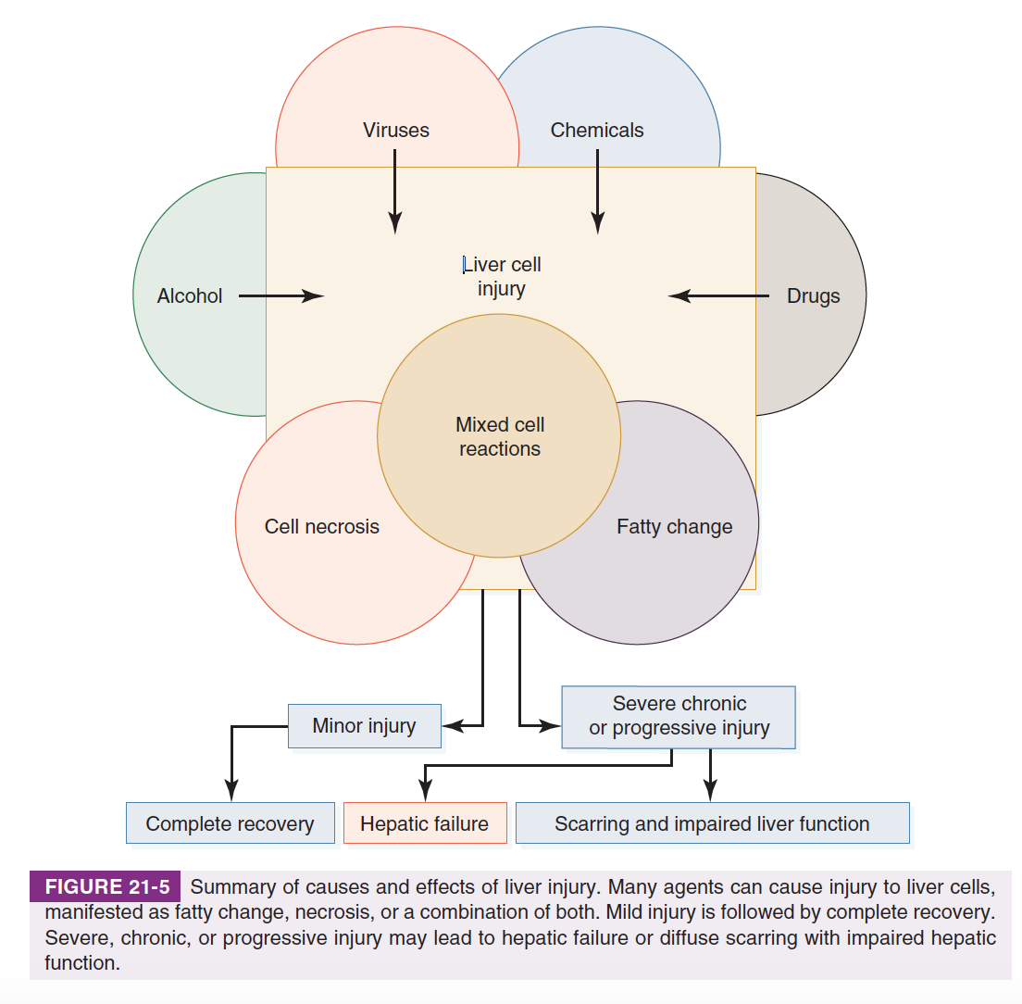
Acetaminophen toxicity:
Acetaminophen (better known by its trade name Tylenol™) has gained popularity as an over-the-counter pain medication and aspirin replacement over the last several decades. Although acetaminophen is generally a safe medication, with a toxic dose (generally considered to be above 8 grams per 8 hours or less) far above the recommended maximum therapeutic dose of 3 grams per day, it is often abused. It may surprise individuals to learn that acetaminophen is responsible for over half of all cases of drug-induced liver injury, almost 80,000 ER visits, and more than 30,000 hospitalizations per year in the United States. Acetaminophen overdose was responsible for more than 500 deaths per year—half accidental, half suicidal and is the second most common cause of acute liver failure requiring transplantation.
Why is acetaminophen Toxic?
About 5 percent of acetaminophen is modified by the cytochrome P-450 enzymes in the liver to a toxic intermediate called NAPQI. NAPQI binds to mitochondrial proteins and leads to the formation of reactive oxygen species, which result in hepatocyte death and, if levels are high enough, acute hepatic necrosis. Cytochrome P-450 enzymes are increased by alcohol consumption, leading to the formation of more of the toxic metabolite NAPQI. The drug used to treat John (N-acetylcysteine) replenishes stores of GSH which detoxifies reactive oxygen species, reducing the toxic effects of NAQPI.
Mechanism and Histology

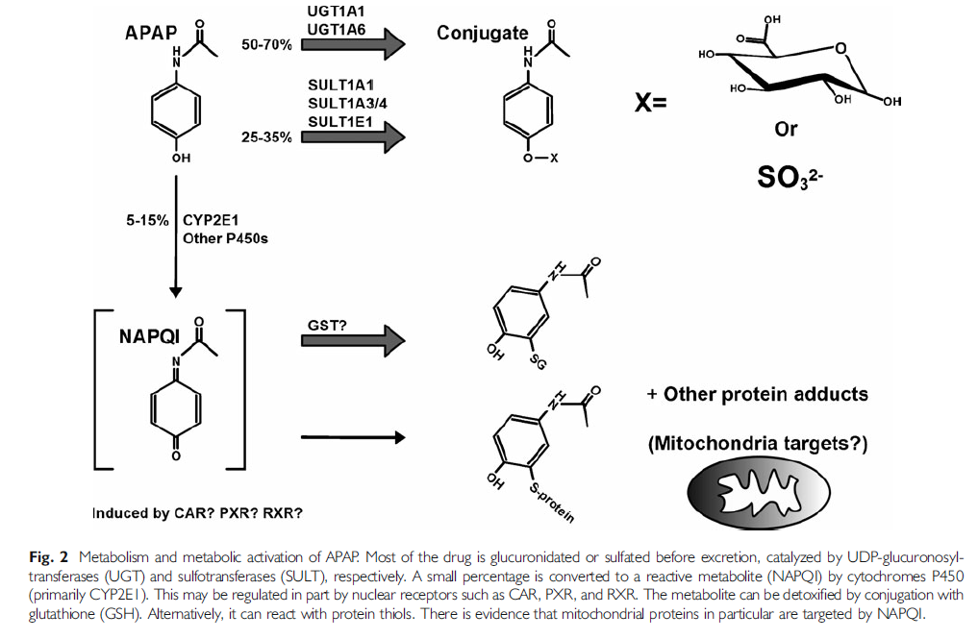
Which pathway leads to toxicity, which does not-Why?

Liver removed at time of transplant demonstrating acetaminophen toxicity

Normal Liver
Identify hepatocytes, portal triad in normal liver

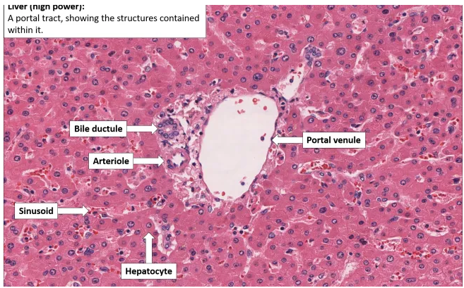
Source is https://bilarasa.com/ good diagram-poor text in source!

What changes have occurred in the affected liver?

