Review Submission Form Example and Link
Spring 2024 LCCC Developmental Fund Proposal Review

Below is an example of the Review Submission Form you will fill out on line.

Please use this link to submit your review
Click Here
or
copy and paste this link
https://unc.az1.qualtrics.com/jfe/form/SV_1YyuUNOYMoPRtL8

If you have a problem with on-line submission email Patty Spears at paspears@med.unc.edu for a paper form to fill out.

Confidentiality Statement: the UNC Lineberger has assured applicants that their identity, their applications, and the associated reviews are held in confidence. Applications, review materials, and meeting proceedings are for the sole use of reviewers and LCCC staff. By agreeing to review, reviewers certify that they understand the confidential nature of the evaluation and promise not to discuss applications under consideration with anyone outside of meeting deliberations.

Review Submission Form
Spring 2024 LCCC Developmental Fund Proposal Review

Committee: Choose an item.
Reviewer Name:
Proposal Title:
Applicant Name:

Patient and/or Community Impact and Relevance

- Has the applicant convinced you of how their research will benefit patients?
- Has the applicant conveyed an understanding of the issues most important to patients, survivors and the community?
- Has the applicant clearly defined the target population and the impact this proposal will have on that population?
- Does the proposal convey a sense of urgency?
- Is this research proposal relevant to cancer patients and/or North Carolina community and population cancer needs and priorities? Explain why or why not.
Strengths:

Weaknesses:

Score: Choose an item.

Scoring Information

Scoring Instructions: If you are assigned proposals for both tiers, Please do not compare Tier 1 applications with Tier 2 applications.

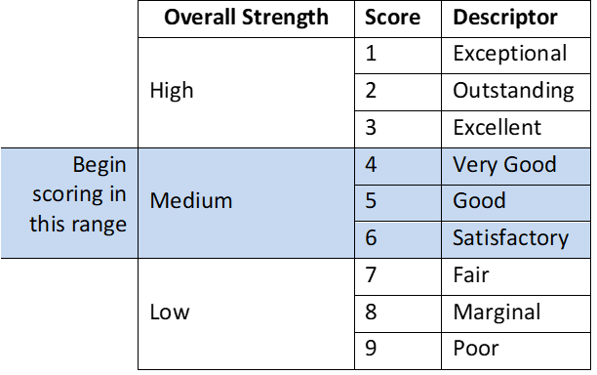
NUMERICAL SCORING GUIDE:
- Use the whole range; start in the middle of the scale and go up or down from about a “4 or 5”
- Use whole number scores only.

